
Green University of Bangladesh
Department of Computer Science and Engineering(CSE)
Faculty of Sciences and Engineering
Semester: (Spring, Year:2024), B.Sc. in CSE (Day)

LAB ASSIGNMENT NO #03

Course Title: Data Communication Lab
Course Code: CSE 308 Section: 221_D3

Experiment Name: IPv4 implementation of Decimal to Binary and vice versa
Student Details

Name |  | ID
1. | Jahidul Islam | 221002504

Lab Date : 16 – 03 – 2024
Submission Date : 20 – 03 – 2024
Course Teacher’s Name : Sakhaouth Hossan

[For Teachers use only: Don’t Write Anything inside this box]

Lab Report Status
Marks: ………………………………… Signature:.....................
Comments:.............................................. Date:..............................

1. TITLE OF THE LAB EXPERIMENT:
IPv4 implementation of Decimal to Binary and vice versa

2. OBJECTIVES:

After complementing this lab experiment, we will gain practical knowledge and tthe outcomes of this experiment are
- To implement ip number conversion.
4. IMPLEMENTATION

An ipv4 dotted binary IP to decimal IP:
// Bismillahir Rahmanir Rahim
// jahidulZaid
#include <bits/stdc++.h>
using namespace std;
#define optimize() ios_base::sync_with_stdio(0);cin.tie(0);cout.tie(0);
#define endl '\n'
#define tt long long t; cin >> t;
#define pb push_back

int main() {
string dottedBinaryIP;
cin >> dottedBinaryIP;
stringstream ss(dottedBinaryIP);
string octet;
string binaryIP = "";
while (getline(ss, octet, '.')) {
binaryIP += octet;
}
bitset<32> binary(binaryIP);
unsigned long decimalIP = binary.to_ulong();
unsigned int octets[4];
octets[0] = (decimalIP >> 24) & 0xFF;
octets[1] = (decimalIP >> 16) & 0xFF;
octets[2] = (decimalIP >> 8) & 0xFF;
octets[3] = decimalIP & 0xFF;
for (int i = 0; i < 4; ++i) {
cout << octets[i];
if (i < 3) cout << ".";
}
cout << endl;
return 0;
}

5. OUTPUT

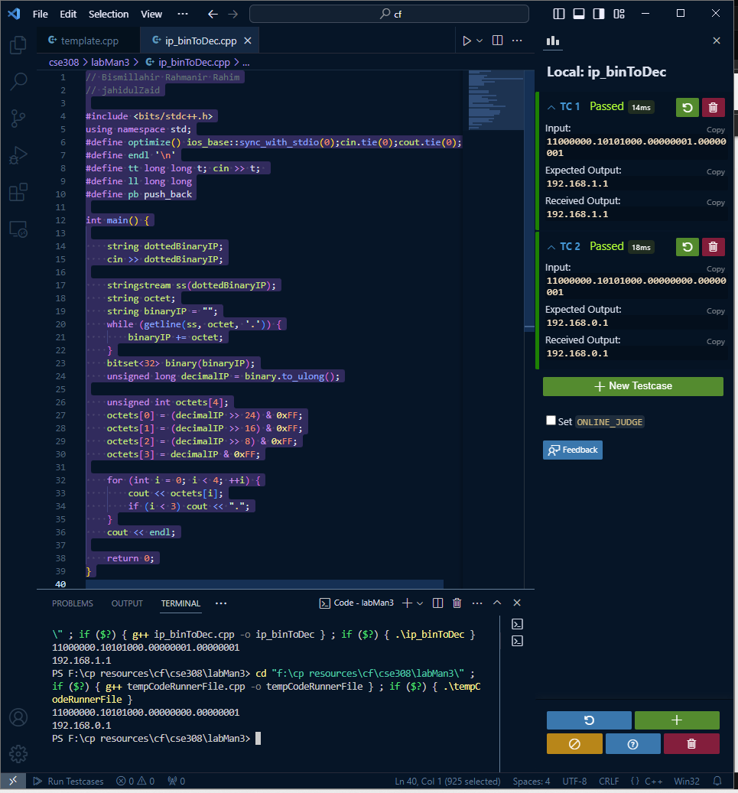

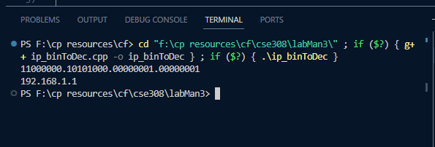

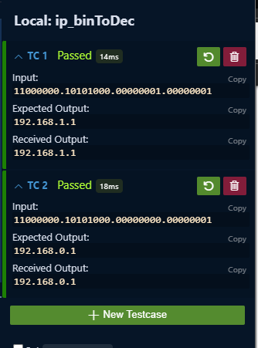

6. ANALYSIS AND DISCUSSION:

After following the above steps we successfully obtained the desired results.

